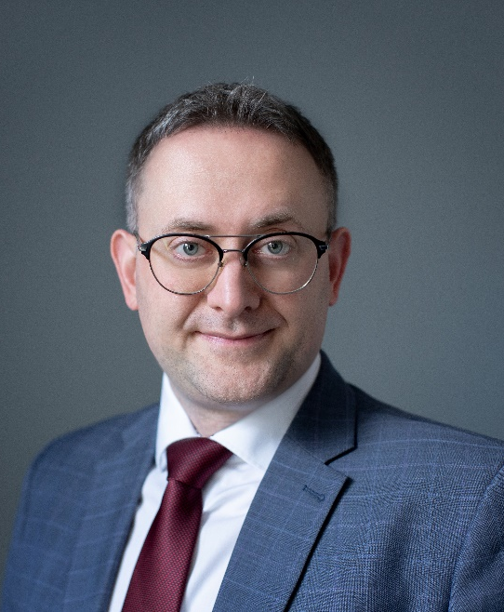
MARKIAN MALSKYY
Managing Partner, Head of West Ukrainian Branch, Dr jur., attorney-at-law, MCIArb
Honorary consul of Austria in Lviv
Co-Head of International Litigation and Arbitration

PRACTICES: International Litigation and Arbitration, Dispute Resolution
INDUSTRIES: Agroindustrial Sector, Energy

In the last 10 years he has been pursuing his professional activities in the field of law, mainly representing the interests of clients in energy, real estate, tax and customs, other legal and arbitration disputes, corporate relations and investments. Markian has substantial experience in defamation claims and succession disputes, representing high net worth individuals in pursuing their rights under estates. He regularly represents clients in debt recovery and enforcement, with a specialization in the area of hospital supply agreements, and the recognition and enforcement of foreign judgments and arbitral awards.
In July-December 2019 was Governor of Lviv region and was named among top-5 most effective governors of Ukraine of 2019 according to Delovaya Stolitsa newspaper. Markiyan was a partner with Kochański & partners, a polish law firm, professor at Warsaw University, where he taught international arbitration and private law in English and Polish.
Author of four textbooks on the resolution of commercial disputes, as well as more than 100 publications on legal topics.

EDUCATION: Taras Shevchenko National University of Kyiv, PhD Hab. (2020)
Taras Shevchenko National University of Kyiv, PhD (thesis "Arbitration agreement as a precondition of dispute resolution in international commercial arbitration") (2012)
World Trade Institute, Master of International Law and Economics (summa cum laude) (Corporate, contract, investment law, international trade) (2007)
Stockholm University, LL.M in International Commercial Arbitration (magna cum laude) (Commercial arbitration, dispute settlement) (2006)
Ivan Franko National University of Lviv, Master of International Economics (International economics, business, finance and financial planning, investments), Master of Law (Civil, financial, corporate, contract, international law) (2006)
RECOMMENDED ARBITRATOR:
- International Commercial Arbitration Court at Ukrainian Chamber of Commerce and Industry (ICAC at UCC);
- Vienna International Arbitral Centre (VIAC);
- Arbitration Court attached to the Czech Chamber of Commerce and the Agricultural Chamber of the Czech Republic;
- China International Economic and Trade Arbitration Commission (CIETAC);
- Chisinau International Court of Commercial Arbitration (CACIC);
- Riga International Commercial Arbitration Court (RICAC);
- Court of Arbitration at Nowy Tomyśl Chamber of Commerce;
- Arbitration Center of Mexico (CAM);
- International arbitration court "Chamber of Arbitrators at the Union of Lawyers" (Belarus);
- Recommended arbitrator in the financial restructuring procedure pursuant to the Law of Ukraine "On Financial Restructuring;
- Korean Commercial Arbitration Board.

REPRESENTATIVE CASES:
Representation of the Government of Ukraine in an investment dispute under the Netherlands - Ukraine BIT and ICSID Convention in banking instruments sphere;
Representing a leading agricultural company in a multimillion investment dispute dealing with sea ports infrastructure;
Representing a Ukrainian State Enterprise in pre-trial settlement of an investment dispute with a foreign state for an overall amount of nearly EUR 5 million;
Representing one of the major oil producing companies in a dispute on collection of more than 200 million USD of losses caused by improper execution of the shareholders agreement;
Representing the interests of a Swiss company in arbitration against the Ukrainian state body under UNCITRAL Arbitration Rules. The dispute originated out of a more than USD 9,5 million contractor agreement and was administrated by the Permanent Court of Arbitration in the Hague;
Reaching a settlement in a dispute between Austrian and Estonian companies pending the consideration by ICAC at the UCCI;
Representation of interests of one of the largest Ukrainian mobile service provider in a dispute with a Russian mobile service provider over fraudulent activities under the Rules of Arbitration of the International Chamber of Commerce;
Representation of interests of one of the leading German telecommunication service providers against one of the largest Ukrainian mobile service provider before International Commercial Arbitration Court under the Ukrainian Chamber of Commerce;
Acted as an Expert Witness and submitted Expert Witness Statement on Ukrainian law and dispute resolution procedure issues in a dispute brought by a businessman, Italian national against one of the leading transnational steel companies in Central and Eastern Europe Region on recovery of debt and damages considered by the High Court of Justice, Queen's Bench Division;
Representing major American energy company in a construction dispute considered in accordance with the ICAC at the UCCI Rules;
Representing a major international banking syndicate in a number of arbitral debt recovery cases against a variety of Ukrainian and foreign borrowers for the sum of nearly USD 700 million;
Representing a major international banking syndicate in a variety of debt recovery cases for the sum of over USD 74 million in different jurisdictions (England, Cyprus). Legal support in the process of preparation of documents for obtaining a worldwide freezing and asset disclosure order, High Court of Justice, Queen's Bench Division in support of the LCIA arbitration.

AUTHOR OF THE BOOKS:
- Recognition and enforcement of foreign arbitral awards in Ukraine;
- Adverse inference in WTO law and other dispute settlement fora;
- Arbitration Agreement. Theoretical and Practical Aspects;
- International enforcement process. Theory and Practice.

RECOGNITIONS AND AWARDS:
Chambers Global 2013–2019, 2021-2022: recommended in Dispute Resolution.
Chambers Europe (2013-2019, 2021-2022): recommended in practice of Dispute Resolution;
The 2013-2019, 2021 edition of The Legal 500 - Europe, Middle East & Africa guide recognized Markian Malskyy as experienced ADR practitioner in the Dispute resolution chapter;
Benchmark Litigation Europe Awards 2020. Dispute Resolution Lawyer of the Year in Ukraine;
Best Lawyers 2019-2022 recommends Markian Malskyy in following practices: Arbitration and Mediation, Corporate Law, International Arbitration, Litigation, Mergers and Acquisitions Law and Real Estate Law
Best Lawyers 2018 named Markian Malskyy Lawyer of the Year in International Arbitration in Ukraine and recommended in 5 other practices –Arbitration and Mediation, Dispute Resolution, Corporate law, M&A, Real Estate and Construction;
Best Lawyers 2013-2022 recommends Markian Malskyy in International Arbitration, Corporate law and M&A;
Markian Malskyy has been highly ranked as the leading expert in international arbitration by "Ukrainian Law Firms. A Handbook for Foreign Clients" (2012-2020);
Markian Malskyy was listed in the rating "Top 100 Best Lawyers in Ukraine - Client’s Choice 2012-2017" in the sphere of international commercial arbitration and litigation;
The International Who's Who of Construction Lawyers 2014: one of leading experts in practice of construction;
The International Who’s Who of Commercial Arbitration 2014: one of leading experts in practice of commercial arbitration;
Markian Malskyy has been recognized the Best Arbitration Lawyer 2014 according to the research conducted by Legal Practice publishing house;
Markian Malskyy was recognized by the study "16 Ukrainian Young and Promising Lawyers 2012" within the framework of the annual rating "Ukrainian Law Firms" of the Legal Practice publishing house.

MEMBERSHIP:
- International Bar Association (IBA);
- American Bar Association (ABA);
- Chartered Institute of Arbitrators (CIArb);
- London Court of International Arbitration Young International Arbitration Group (LCIA YIAG);
- Institute for Transnational Arbitration (Young ITA);
- Young Austrian Arbitration Practitioners (YAAP);
- Swiss Arbitration Association (ASA below 40);
- ICDR (International Centre for Dispute Resolution Young & International);
- The Belgian Centre for Arbitration and Mediation (Cepani 40);
- ICC Young Arbitrators Forum (YAF);
- Ukrainian Bar Association (UBA);
- Association of attorneys of Ukraine (AAU), Head of Lviv branch;
- European Business Association (EBA), Head of the Coordination Council of West Ukrainian Branch (2015-2016; since 2021), Member of the Coordination Council (2010-2019), Head of the Legal Committee (2009-2014);
- Ukrainian Arbitration Association (UAA), Member of the Board in 2012-2019, Counsel to the Board since 2020.

LANGUAGES: Ukrainian, English, German, Polish.

