PERSONAL INFORMATION | Prof. Dr. Vuk Cucić, FCIArb
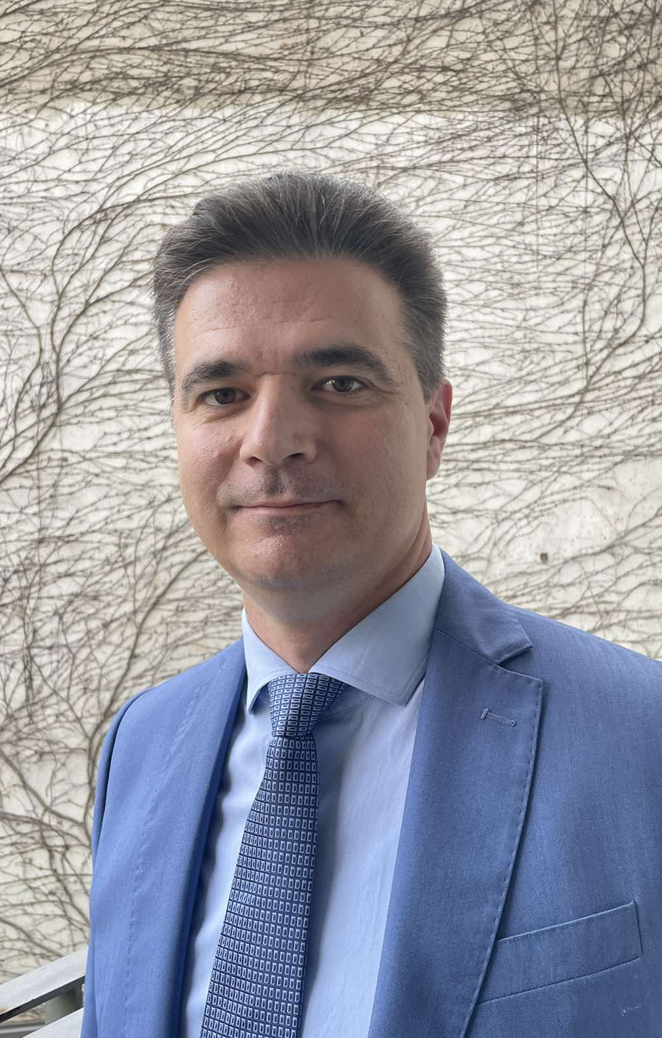 | 11 Čuburska, Belgrade, 11000, Serbia
 | +381 11 3027600 +381 64 2451798
 | vukcucic@gmail.com, vukcucic@ius.bg.ac.rs
 | Sex M | Date of birth 17/08/1983 | Nationality Serbia

WORK EXPERIENCE

2008 - | Full Professor
2008 - | FACULTY OF LAW, UNIVERSITY OF BELGRADE
2008 - | - Administrative Law, Administrative Procedural Law, Comparative Judicial Control of Administration  - Vice-Dean for Finance 2020-2024
2023 -  2021 -  March – December 2014 | Arbitrator  CHARTERED INSTITUTE OF ARBITRATORS, UK  - Fellow since 2026  PERMANENT ARBITRATION AT THE CHAMBER OF COMMERCE AND INDUSTRY OF SERBIA  - Acted as arbitrator in international and domestic commercial arbitrations  Expert Witness  ICSID, ICC  - Appeared as an Administrative Law expert witness in investment arbitration disputes concerning South-East European countries (cases concerning telecommunication market, real estate, privatization and waste treatment)  Consultant for Administrative Court System
2023 -  2021 -  March – December 2014 | WORLD BANK, MINISTRY OF JUSTICE
2023 -  2021 -  March – December 2014 | - Preparation of analyses and pre-drafts of laws necessary for introduction of a two-tier administrative judiciary
2012 - 2014 | Special Adviser to the Minister of Justice and Public Administration
2012 - 2014 | MINISTRY OF JUSTICE AND PUBLIC ADMINISTRATION
2012 - 2014 | - In charge of public administration, e-Government, drafting of legislation and strategic documents
2007 - 2008 | Associate
2007 - 2008 | Law Firm MORAVCEVIC VOJNOVIC ZDRAVKOVIC OAD IN COOPERATION WITH SCHÖNHERR

EDUCATION AND TRAINING

2024  2009 - 2015 | Executive Course on Investment Law and Arbitration  QUEEN MARY UNIVERSITY OF LONDON, UK  PhD | PhD
2024  2009 - 2015 | FACULTY OF LAW OF THE UNIVERSITY OF BELGRADE, Serbia
July - August 2013, August 2014 | Research Stay | Study stay
July - August 2013, August 2014 | MAX PLANCK INSTITUTE FOR INTERNATIONAL LAW AND COMPARATIVE PUBLIC LAW, Heidelberg, Germany
July 2011  February - October 2010 | 2011 Annenberg-Oxford Summer Institute on Media Law and Policy OXFORD UNIVERSITY, Oxford, UK  PhD Exchange | PhD Exchange
July 2011  February - October 2010 | GHENT UNIVERSITY, Ghent, Belgium
2007 - 2009 | LLM | LLM
2007 - 2009 | FACULTY OF LAW OF THE UNIVERSITY OF BELGRADE, Serbia
2002 - 2007 | Graduated Jurist – International Law (LLB) | LLB
2002 - 2007 | FACULTY OF LAW OF THE UNIVERSITY OF BELGRADE, Serbia

PERSONAL SKILLS

Mother Tongue | Serbian
Other Languages | UNDERSTANDING |  | SPEAKING |  | WRITiNG
Other Languages | Listening | Reading | Spoken interaction | Spoken production
English | C1 | C1 | C1 | C1 | C1
(CAE, C1)
French | B2 | B2 | B2 | B2 | B2
(Alliance Française B2)
German | B2 | B2 | B2 | B2 | B2
(Göthe-Zartificat B2)
Spanish | B1 | B1 | B1 | B1 | B1
(DELE B1)
Russian | A2 | B1 | A1 | A1 | A1
(self-assessment)

ADDITIONAL INFORMATION

PUBLICATIONS  LEGISLATION DRAFTING  PROJECTS  MEMBERSHIP IN PROFESSIONAL ORGANIZATIONS | BOOKS:  - Postupak zaštite konkurencije u Srbiji [Competition Protection Procedure in Serbia];  - Административное судопроизводство Республики Сербия [Administrative Judicary in the Republic of Serbia]. Монография: Опалев, Рим, Цуцич, Вук, Мишкович, Маша, Статут, Москва, 2021;  - Sprovodjenje i kontrola postupka javnih nabavki [The Realization and the Control of the Public Procurement Procedure], Official Gazette, Belgrade, 2020, pp. 174;  - Praktikum za primenu Zakona o opštem upravnom postupku [Handbook for Application of the Law on General Administrative Procedure], (with Zoran Tomić and Dobrosav Milovanović), Ministarstvo državne uprave i lokalne samouprave, Beograd, 2017;  - Priručnik za polaganje državnog stručnog ispita - Upravni postupak [Handbook for State Exam for Civil Servants], (with Zoran Tomić and Dobrosav Milovanović), Ministarstvo državne uprave i lokalne samouprave, Beograd, 2017;  - Zbirka propisa iz oblasti upravnog prava [Collection of Regulations in the Field of Administrative Law], Official Gazette, Belgrade, 2019, pp. 684;  - Upravni spor pune jurisdikcije – Modeli i vrste [Administrative Dispute of Full Jurisdiction – Models and Types], Pravni fakultet Univerziteta u Beogradu, Beograd, 2016, pp. 382.  ARTICLES:  - “Administrative Law Challenges in Investor-State Arbitration”, Journal of International Arbitration, Vol. 41/5 (2024), Wolters Kluwer (623-646); (translated also into Arabic and published in the Journal of the Saudi Arabian Institute of Public Administration - https://www.ipa.edu.sa/ar/publications/MagazineFiles/arabic/u9m5zbVnk0aRH_yFkxBSBQ.pdf)  - “Simulated Appellate Protection within Serbian Local Governments” (with Dobrosav Milovanovic), Teme, University of Niš, 2025, https://doi.org/10.22190/TEME240101001C;  - “Hitting not only the Target – The Indirect Review of Administrative Action in Serbia and Croatia”, in Indirect Judicial Review in Administrative Law - Legality vs Legal Certainty in Europe (eds. Mariolina Eliantonio and Dacian Dragos), Routledge, London, 2022, pp. 149-168;  - „Nadzor u oblasti digitalne imovine“, Pravo i privreda, Udruženje pravnika u privredi, br. 2/2023 (356-381);  - ”Prividna jednostepenost postupka javnih nabavki – Ustavni sud opet u ulozi ‘pozitivnog zakonodavca’”, Pravo i privreda, Udruženje pravnika u privredi, br. 4/2023 (1028-1044);  - ”Neustavnost Zakona o opštem upravnom postupku – Ustavni sud kao ”pozitivni zakonodavac”, Zbornik radova Pravnog fakulteta u Nišu, br. 98/2023 (175-193);  - ”'Sukob nadležnosti’ kod sukoba nadležnosti u upravnom postupku”, Pravo i privreda, Udruženje pravnika u privredi, br. 3/2024 (395-412);  - ”(U)skraćivanje prava na pomoć i negu drugog lica – ograničena retroaktivnost rešenja”, Zbornik radova „Pravne praznine i punoća prava“, Tom II, Univerzitet u Istočnom Sarajevu - Pravni fakultet (72-91);  - “Contagious Spreading of the Executive Power During the Pandemic”, Zbornik radova 11. međunarodne konferencije Razvoj javne uprave, Veleučilište Lavoslav Ružička Vukovar, Pravos, Vukovar, 2021 (57-69);  - ”Upravno pravo u socijalističkoj Jugoslaviji – Postojana klisurina ili lomljivi dub”,u Socijalističko pravo u Jugoslaviji 1945-1990 (ur. Dejan Popović, Boris Begović, Zoran Mirković), Univerzitet u Beogradu – Pravni fakultet, 2024 (825-844);  - “Fault in the Law on General Administrative Procedure”, in Law on General Administrative Procedure: Contemporary Tendencies and Challenges (eds. Srečko Devjak, Predrag Dimitrijević), Eurosfera, The Institute of Comparative Law; MLC Faculty of Management and Law, Ljubljana, 2024 (307-321);  - “Impenetrable Wall of Administrative Silence in Serbia”, Zbornik radova Pravnog fakulteta u Nišu, br. 93, 2021, pp. 63-77;  - “Europeanization of General Administrative Procedure in Serbia”, Review of Central and East European Law, no. Vol. 46, Issue 2, 2021, pp 153-178;  - “Administrative Law Challenges of Post-Clearance Audit in Serbia”, Belgrade Faculty Law Review, Faculty of Law of the University of Belgrade, no. 1/2021, pp. 231-249; Also published in Russian - ”Проблемы административного законодательства в отношении пост таможенного аудита в Сербии”, Таможенные споры. Банковские и страховые споры, Материалы Всероссийских научно-практических Конференций (20 ноября 2020 г., 28 мая 2021 г.), И.А. Цинделиани, Т.А. Вершило (ур.), Российский государственный университет правосудия (35-53));  - ”The Pan-European General Principles of Administrative Law - the Serbian Legislator's Inspiration and Conscience”, in Good Administration and the Council of Europe: Law, Principles, and Effectiveness, Stelkens, Ulrich, Andrijauskaité, Agné (eds.), Oxford University Press, 2020;  - ”The Privilege of Silence in Serbian Administrative Law”, in The Sound of Silence in European Administrative Law, Dragos, Dacian et alia (eds.), Springer, 2020, pp. 371-398;  - Free Access to Information in Serbia (with Dobrosav Milovanović and Marko Davinić), The Laws of Transparency in Action – A European Perspective, Palgrave Macmillan, 2019, pp. 501-541;  - ”Postupak resavanja upravnih sporova”, ”The Procedure of Resolution of Administrative Disputes”, Zbornik radova 150 godina upravnog spora u Srbiji: 1869-2019, Collection of Papers 150th Anniversary of the Administrative Dispute in the Republic of Serbia, Vuk Cucić (ed.), Administrative Court of Serbia, Faculty of Law of the University of Belgrade, Belgrade, 2019, pp. 135-175 (paper is published in the same book both in Serbian and English);  - История развития и актуальное состояние судебного контроля за деятельностью административных органов в Сербии, Журнал Судья, Supreme Court of Russian Federation, no. 3. 2018, pp. 53-64. Published also as ”Historical and contemporary development of judical control of administration in Serbia”, Зборник Идентитетски преображај Србије, Правни факултет Универзитета у Београду, Београд, 2018, стр. 181-202;  - The European Administrative Space - Instrument for Transforming the Serbian Administrative Law System (with Marko Davinic), in Matei, A., Sandu, C., Enlargement of the European Administrative Space. Public Administration Reforms on the road to E.U. Membership, Scholars' Press, 2017, pp. 223-246;  - Reforma upravnog sudstva u Srbiji [Administrative Judiciary Reform in Serbia], Pravni zivot, Udruzenje pravnika Srbije, Beograd, 2016, pp. 151-164;  - Nova rešenja Nacrta zakona o opštem upravnom postupku u kontekstu reforme javne uprave u Srbiji [New Solutions of the Draft General Administrative Procedure Act in the Context of the Public Administration Reform in Serbia], (with Dobrosav Milovanović), Pravni život, no. 10, tom II, Beograd, 2015, pp. 95-110;  - Unapređenje poslovnog okruženja u Srbiji u svetlu novih rešenja Nacrta zakona o opštem upravnom postupku [Business Environment Enhancement in Serbia in the Light of the New Solutions of the Draft General Administrative Procedure Act], (with Dobrosav Milovanović), Usklađivanje poslovnog prava Srbije sa pravom EU (ed. Vuk Radović), 2015, pp. 445-469;  - Serbia as a Part of the European Administrative Space: ADR Tools Applied to Administrative Law, Alternative Dispute Resolution in European Administrative Law, Dacian, Dragos, Bogdana, Neamtu (eds.), Springer, 2014, pp. 461-488;  - Interne und externe Kontrolle der serbischen Polizei (Internal and External Control of Serbian Police), (with Christoph Hofstaetter) Polizei Recht in Osteuropa, Osteuropa Recht, no. 1/2014, Berlin, pp. 42 -59;  - Francusko upravno sudstvo: Velicanstveno delo Francuske istorije [French Administrative Judiciary: Marvelous Deed of the French History], Pravni zivot (Legal Life), no. 10/2013, Association of Jurists of Serbia, Belgrade, pp. 283 – 302;  - Registracija javnih glasila [Media Outlet Registration], Zbornik radova Pravnog fakulteta u Nisu (Review of Nis Faculty of Law), Faculty of Law of the University of Nis, thematic issue “Media and Human Rights”, no. 61, 2012, pp. 421 – 438;  - “Efficiency of the Administrative Appeal (The Case of Serbia) in Special Administrative Domains“, Transylvanian Review of Administrative Sciences, No. 37 E/2012, pp. 95 – 111 (with Dobrosav Milovanovic and Marko Davinic);  - “Appeals in Special Administrative Domains“, Transylvanian Review of Administrative Sciences, No. 34 E/2011, pp. 63 – 79;  - “Administrative Appeal in Serbian Law“, Transylvanian Review of Administrative Sciences, No. 32 E/2011, pp. 50 – 73;  - “Extraordinary Administrative Legal Remedies in Serbian Law“ – 8th Biennial International Conference, Universul Juridic, Bucharest, 2011, pp. 74 – 84;  - Strazburski standardi u upravnom sporu [Strasbourg Standards in Administrative Dispute], Anali Pravnog Fakulteta u Beogradu (Belgrade Faculty Law Review), Faculty of Law of the University of Belgrade, no. 2/2009, pp. 247 – 272;  - Primena prava na pravicno sudjenje u upravnom sporu [Application of the Right to Fair Trial in Administrative Dispute], Pravni zivot (Legal Life), Association of Jurists of Serbia, no. 10/2009, pp. 261 - 271.  MEMBER OF THE WORKING GROUPS IN CHARGE OF DRAFTING:  - Law on Administrative Disputes – Ministry of Justice, October 2014 – February 2016;  - Law on Inspection Supervision - Ministry of Justice and Public Administration, June 2013 – January 2014;  - Public Administration Reform Strategy - Ministry of Justice and Public Administration, January 2013;  - Law on Regional development - Ministry of Regional Development and Local Self-Government, April 2013:  - Law on Local Self-Government– Ministry of Regional Development and Local Self-Government, November 2012;  - Law on General Administrative Proceeding– Ministry of Justice and Public Administration, October 2012 – May 2016;  - Law on Mass Media– Ministry of Culture, Information and Information Society February – May 2012.  GIZ expert for the harmonization of special laws with the Law on General Administrative Procedure – 2017-2019 (developing methodology for the harmonization and monitoring application of the developed methodology).  The development of pan-European general principles of good administration by the Council of Europe and their impact on the administrative law of its Member States, German Research Foundation, organized by Ulrich Stelkens since 2017.  Improving Administrative Efficiency and Effectiveness at the Local Level, Standing Conference of Towns and Municipalities, since 2018.  Good Governance Index on Local Level – Standing Conference of Towns and Municipalities, 2018.  Online Video Training for the Law on General Administrative Procedure - National Academy for Public Administration, 2018.  Training for civil servants – Novelties of the new Law on General Administrative Procedure and the Law on Inspection Oversight more than 40 trainings in organization of the Standing Conference of Towns and Municipalities, National Academy for Public Administration, Council of Europe – since 2016.  Development of administrative procedure models - Standing Conference of Towns and Municipalities - 2016.  One-Stop-Shop system in the Western Balkan, Regional School for Public Administration, 2015.  MDTF-JSS (World Bank) Consultant for Administrative Courts System, Ministry of Justice and Public Administration, introduction of two-tier administrative judiciary in Serbia, 2014  Chartered Institute of Arbitrators (CIArb)  ReNEUAL (Research Network for EU Administrative Law)  Centre for Public Administration and Public Procurement, Faculty of Law, University of Belgrade

